**Confusion Matrix For Multi-class Classification**

Now, let’s consider there are three classes. A 3X3 Confusion matrix is shown below for the image having three classes.

Here, TP= True Positive , FP= False Positive , FN= False Negative.

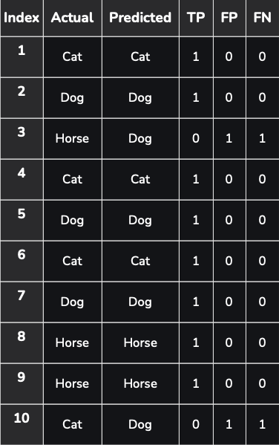

True Positives (TP): 8 (1+1+0+1+1+1+1+1+1+0)

False Positives (FP): 2 (0+0+1+0+0+0+0+0+0+1)

False Negatives (FN): 2 (0+0+1+0+0+0+0+0+0+1)

A 3X3 Confusion matrix is shown below for three classes.

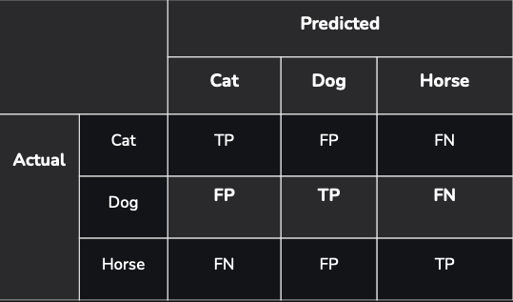

Class-wise Summary:

**For Cat: [TP=3,FP=0,FN=1]**

Index 1: True Positive (Cat actual, Cat predicted)

Index 4: True Positive (Cat actual, Cat predicted)

Index 6: True Positive (Cat actual, Cat predicted)

Index 10: False Negative (Cat actual, Dog predicted)

**For Dog: [TP=3,FP=2,FN=0]**

Index 2: True Positive (Dog actual, Dog predicted)

Index 5: True Positive (Dog actual, Dog predicted)

Index 7: True Positive (Dog actual, Dog predicted)

Index 10: False Positive (Cat actual, Dog predicted) I

ndex 3: False Positive (Horse actual, Dog predicted)

**For Horse: [TP=2,FP=0,FN=1]**

Index 8: True Positive (Horse actual, Horse predicted)

Index 9: True Positive (Horse actual, Horse predicted)

Index 3: False Negative (Horse actual, Dog predicted)

Then the Confusion Matrix will be:

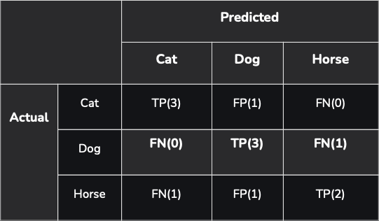

Implement the Confusion Matrix for binary classification using Python.